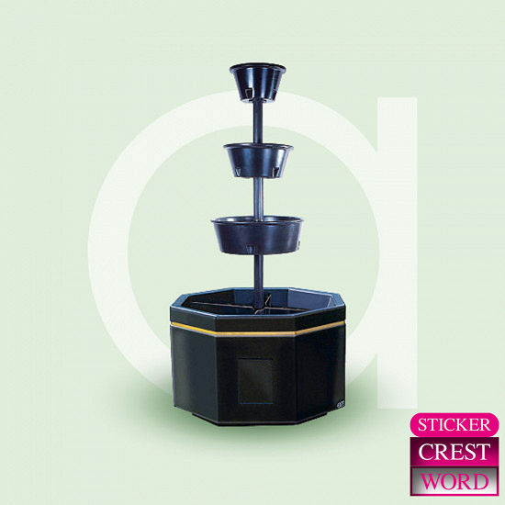
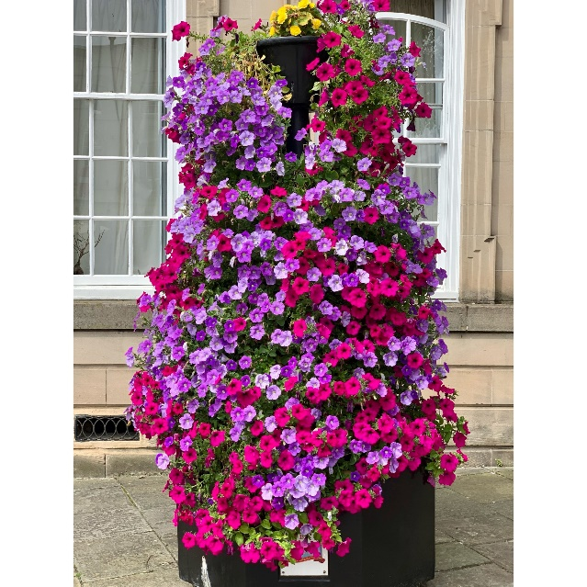
Amberol, the supplier of our Warwick in Bloom planters recently ran a national photo competition on social media. It was announced on Tuesday 31st October that Warwick had won the competition with the photo below. These tower planters are in the Market Square and are sponsored annually by Warwick Castle. As the winner, we have won a £300 gift voucher towards a new planter in the town centre.

Businesses have recently been invited to sponsor a planter in the town centre for £50 annually – in return we will install a Foamex plaque on the planter to recognise their business. This scheme has been very successful, and we have been oversubscribed with sponsors.
Proposal: We purchase a new octagonal planter to be installed at Warwick Bus Station and invite businesses to sponsor the remaining cost of the planter. In return we will install a plaque on this planter for each business who contributes to the cost.

Costs (excluding VAT)
New planter - £777
Winter planting - £69
Summer planting - £185
Total cost for the first year - £1,031

Income
Amberol voucher - £300
8 Businesses @ £50 each - £400
Total income for the first year £700

For the first year, there will be a cost of £331 to Warwick Town Council (difference between income and costs). However, after the first year this will generate an income of £400 annually and only cost Warwick Town Council £254 each year for planting costs.

King Henry VIII charity have also contacted the office to enquire the cost of them purchasing an additional tower planter for the bus station, which will be sponsored annually by the charity. This will be discussed at their upcoming meeting in November.

Having 2 new planters at the bus station will create a great welcome to Warwick at a main entrance into town.

