Report to Warwick Town Council
Funding: £3,000
For: Office extension at The Gap
Introduction
The Gap provides a wide range of services for the local community and those services fall into 3 categories:
- Young People
- Older Adults
- Community
The need for the office extension
The Gap has grown its team in the last few years as we have seen an increased demand in our services. During COVID, staff were working from home but since we have returned to face-to-face delivery, office space has always been a challenge. Staff had to use rooms that we normally hire, which has resulted in a loss in potential income through room rental, which is 20% of our total income. The current office space only allowed up to 2 people and the need is to accommodate up to 4 at a time.
Below is the picture of the old office:
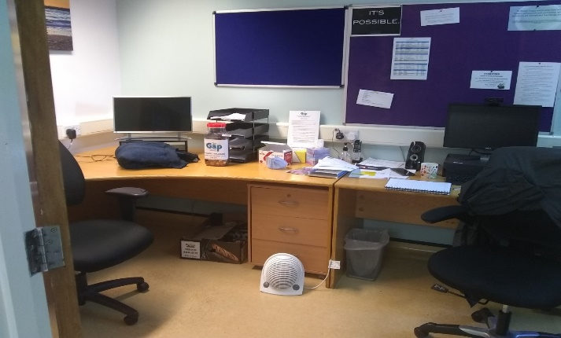

Outcome
The £3,000 funding from Warwick Town Council helped us to extend our office and at least double the capacity. The building was finished mid-March and staff are now setting up their desks.
The funding has not only allowed us to accommodate our growing team, but it has also helped us to use the rooms once used by the staff for room rental to generate important income for our charity.

Thank you, Warwick Town Council, for your support with this project.

Marcos Campos
Director

Please see pictures of before and after:

