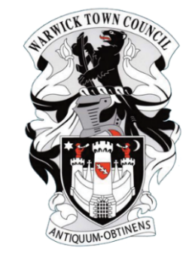

REPORT

To: Allotments Committee, Warwick Town Council
- Purpose: The purpose of this report is to update the Allotments Committee on the work undertaken by the Allotments Administrator (the Administrator) since the last meeting.

- Background: The administration of the Council’s allotment sites is carried out by the Administrator who is the Assistant Town Clerk. The Administrator is required to submit a report to each Allotments Committee meeting, and this is that report.

- Report:

- Tenancies and Lettings:

Since the last meeting on 4th September 2023, site inspections at Cape Housing and Railwayside have resulted in the following outcomes:

- Cape Housing – plots 1A, 2A2, 21A and 21B relinquished after notices to improve. Plots 1A and 2A2 retenanted.

- Railwayside – plots 7A, 8A and 11A relinquished after notices to improve. Plots 4B2, 10, 17A and 20B have given notice. Second letters to plots 3B and 7B have had no response to date.
Plots 7A, 8A and 17A have been retenanted.

- Incident of ASB on Railwayside in October at bottom of site – PCSO meeting onsite 24th November 2023.

- Awaiting written quote via Cliff re replacing the post and moving the gate further down the fence.

- New signs designed and being produced for Railwayside and Cape Housing.

- Waiting lists:

Myton Green – 37
Cape Housing/Railwayside – 32

- Myton Green:

- Lease is now signed by WTC and WDC.
- Meeting with a rep from the Myton Green Committee has been requested to go through the draft documents (lease, grant application, waiting list, rules and regulations)
- Car park surface compacted as agreed with WDC Green Spaces.
- Fallen tree branch removed from site.
- Meeting set to discuss land transfer with solicitors – 11th December 2023

- Recommendations: The committee is asked to note this report.

Katherine Geddes
Assistant Town Clerk
17th November 2023

