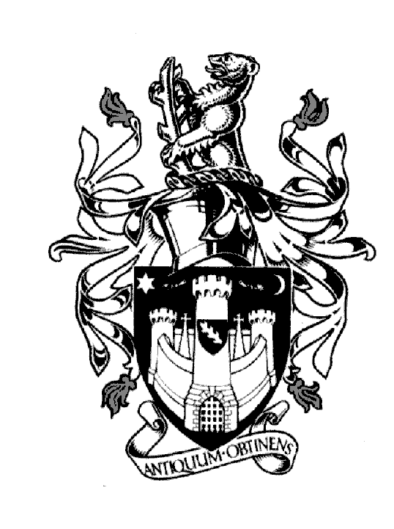
WARWICK TOWN COUNCIL

Court House
Jury Street
WARWICK
CV34 4EW
Tel: 01926 411694

Jayne Topham
Town Clerk

PLANS COMMITTEE

WEDNESDAY 1st DECEMBER
Present:
Councillor P S Birdi Councillor Mrs L Butler
Councillor N Butler Councillor S Cross
Councillor J Darcy Councillor Ms M Noone
Councillor N Murphy
The Mayor (Ex Officio)
MINUTES
228. Apologies - None

229. Declarations of Personal and Prejudicial Interests -Cllr Birdi – W/21/1918

230. Approve minutes of the meeting held on 27th October 2021 – it was resolved to approve the
minutes as a true record.

231. Warwick Castle – planning applications 2022 – Matt Halford ran through a presentation.
A planning application has been submitted to change the location of the overflow carpark on the
Stratford Road. The Folk Festival will not be affected.
Plans for a 60 Bed Hotel were shared. The application will be submitted in January 2022.
The location will be in the car park adjacent to the Knight’s village. The site was selected to ensure
the least effect on the landscape.

232. Review Decisions of the Local Planning Authority –– reviewed no comments

233. Planning Applications for Warwick - schedules reviewed one part 2 application was bought
forward. W/21/1372 – a comment was made to agree with the Conservation Officer.

The following objections were made:

W/21/1982 | 2 The Grange | Warwick Town Council objects to this application on the basis that the proposed dormers do not conform with design guide or street scene
W/21/1555 | 2 Wordsworth Av. | Warwick Town Council objects to this application, as the outdoor amenity space of the existing house will be reduced to approx.  27 m2 which is below the 50 m2 required in the WDC Design Guide.

The following comments were made:

W/21/1918 | Longacre Harbury Land | Whilst Warwick Town Council raises no objection to the outline aspect for the self-build units, subject to the Highway Authority being satisfied with the proposals. The Town Council does object to the current proposals for the two detached residential dwellings by virtue of the scale, bulk and mass which appear incongruous to the character and appearance of the area, and detrimental to the amenity of neighbouring residents. As a result, the proposal is contrary to Paragraph 130 of the NPPF and adopted design policies set out within the adopted Local Plan.

234. Appeals November – reviewed no comments

Signed……………………………………… Dated………………………………………….

