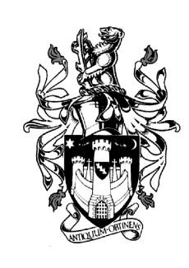
WARWICK TOWN COUNCIL

Court House
Jury Street
WARWICK
CV34 4EW
Tel: 01926 411694

Jayne Topham
Town Clerk

SPECIAL COUNCIL MEETING

28th JUNE 2023

MINUTES

Present:
The Mayor Cllr S Pargeter
Cllr D Browne Cllr J Sinnott
Cllr J Darcy Cllr D Skinner
Cllr Mrs K Dray Cllr J Sullivan
Cllr M Edwards Cllr P Wightman
Cllr Ms K Gorman
Cllr R Kang

20. Apologies: Apologies were received from Cllr Ms E Harrison, Cllr Mrs M Mangat & Cllr A Murphy.
It was resolved to accept their apologies.

21. Declarations of Interest: None

22. Minutes of Mayor Making Special meeting 16th May 2023 – It was resolved to approve the minutes as a

true record.

23. Annual Governance Statement 2023– Following a discussion the Town Clerk read out each statement.

Councillors unanimously returned Yes to boxes 1 to 8 Box 9 was not applicable.

24. Accounting Statement 2022/23 – Councillors reviewed the accounting statement presented by the RFO
It was unanimously approved. Thanks were given to the Town Clerk and the Finance Officer for their had
work.

25. Finance Regulations – appoint a Councillor to be internal auditor – Cllr Ms K Gorman agreed to take on this
role.

26. Civic Manual – ratify approved amendments – It was resolved to approve the amendments proposed with
the inclusion of Vapes next to smoking.

Signed………………………………………………. Dated…………………

