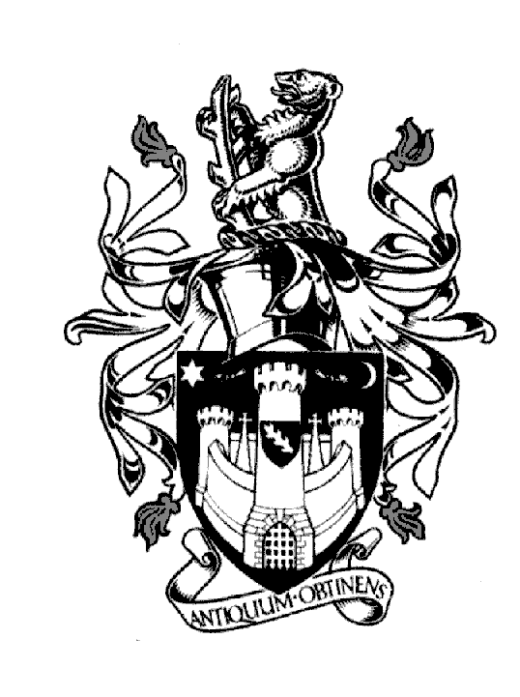

WARWICK TOWN COUNCIL

Court House
Jury Street
WARWICK
CV34 4EW

Tel: 01926 411694
Jayne Topham
Town Clerk

FULL COUNCIL MEETING

30th MARCH 2023

MINUTES

Present:

The Mayor
Cllr M Ashford
Cllr Mrs L Butler
Cllr N Butler
Cllr S Cross
Cllr R Eddy
Cllr R Edgington
Cllr O Jacques
Cllr T Morris
Cllr N Murphy
Cllr D Skinner
Cllr J Tracey

Section A Council

335. Prayers were led by the Town Clerk.

336. Mayor’s announcements – The Mayor summarised the events he had attended.
This is the last Full Council meeting of this administration. Thanks, passed to
Members.

337. Apologies Cllrs J Darcy, Mrs MA Grainger & Ms M Noone sent their apologies it
was resolved to accept their apologies.
WDC Cllr L Bartlett also sent his apologies.

338. Declarations of Interest - None

339. Approve the Minutes of the Council Meeting held on 18th January 2023 – it was
resolved to approve the minutes as a true record.

340. Policing in Warwick – PCC P Seccombe T D, Chief Inspector Faz Chishty and
Insp Simon Ryan SNT representative.
P Seccombe summarised the structure changes to South Warwickshire policing.
Staff levels are increasing and the focus is engagement.
Insp Ryan is responsible for Warwick – the Town Clerk will arrange regular
contact with him.

341. Reports to be received from District or County Councillors – reports were
circulated no questions were raised.

342. Reports of Plans Committee

To receive and adopt the Reports of the Plans Committee meeting held on
23rd February & 23rd March 2023.

It was resolved to approve the minutes as true record.

Cllr T Morris requested for WTC representation at WDC planning meetings when
WTC has raised an objection.

343. Reports of Committees
To receive and adopt the reports of the following committees:

- Allotments Committee meeting 13th February 2023
- Community & Culture 16th February 2023
- Economic & Tourism 22nd February 2023
- Finance and Policy 16th March 2023

It was resolved to approve the minutes as true record.
Cllr R Eddy confirmed that the Coronation plans were approved to go ahead.

344. Election of Mayor and Deputy Mayor 2023/24
The Mayor asked for nominations for Mayor and Deputy Mayor for the
new administration. Our current Deputy Mayor Cllr N Butler was elected to
become Mayor Elect and Cllr O Jacques was elected to become Deputy Mayor
Elect. There were no other nominations.

345. To answer members’ questions - None

Section B General Purposes

346. Public Question Time – A question was raised about the need for Warwick to
have a neighbourhood plan. The Mayor clarified that a change in planning
means that the neighbourhood plan is being replaced. When the new plan is
known the Town Council will carry out a review.

347. Approve revised policies:

- Reserve Policy
- Financial Regulations
- Civic Code of Conduct
- Grants Policy

It was resolved to approve all policies.

348. Risk Register – Cllr N Butler reviewed the outcome from Finance & policy’s
Meeting. It was resolved to approve the additional risk due to the migration of
the finance system from Sage to EdgeIT

349. Revised committee meeting dates. Approve changes:
E & T April 27th to be moved to 25th due to the partnership meeting.
F & P May 11th to the 2nd May due to the elections.
It was resolved to approve the dates stated.

350. Committees – approve Cllr M Ashford to added to Community & Culture and
removed from planning. Cllr N Butler to be added to planning.
It was resolved to approve the committee changes.

351. Calendar of meetings for 2023/24 – It was resolved to approve all dates.

352. Grants – approve
Warwick A Singing Town £5K
Warwick Court Leet £3,087
It was resolved to approve both grants subject to Warwick A Singing Town
evidencing a new bank account.

Signed…………………………………………. Dated……………………………………….

