Warwick Town Council
Walter Savage Landor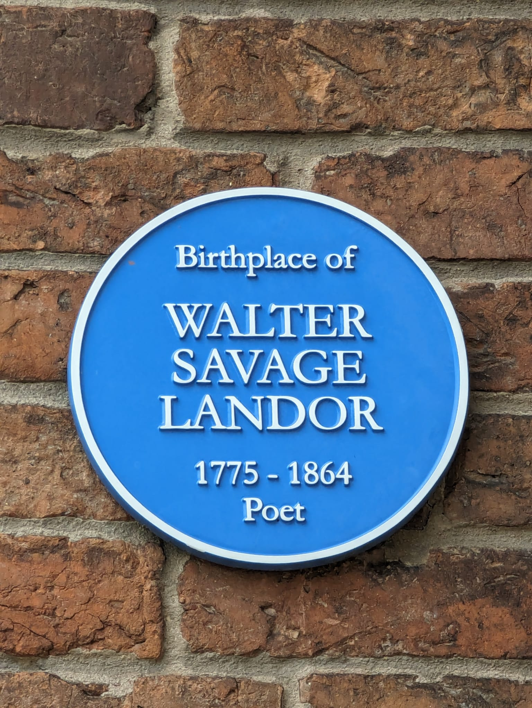
WALTER SAVAGE LANDOR
(1775-1864)
Walter Savage Landor, born at Eastgate House, Smith Street, Warwick was an English writer, poet and activist.

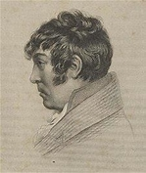

Landor was the eldest son of very wealthy parents - Dr Walter Landor (1733-1805) who was a physician and his second wife Elizabeth, one of four daughters and heirs of Charles Savage from Tachbrook, Warwickshire. His birthplace, Eastgate House, later became occupied by the King’s High School for Girls.
Landor attended school in Knowle and was then sent to Rugby School under Dr James, he was removed from here after taking offence of the headmaster’s review of his work. He then studied privately.
Landor’s temperament and opinions were not welcomed in the home and he was asked to disappear when guests were around.
In 1793 he entered Trinity College; his time here was short-lived. He had fired a gun at the windows of a Tory who disturbed him late at night. Although he could have returned, he refused to, which, led to an argument with his father. Landor then went to Tenby and met Nancy Evans, some of his earliest poems were written for her. Landor’s father disapproved and moved him to London.

Landor’s biography consists of a catalogue of incidents and misfortunes, many of them self-inflicted but some of no fault of his own. His headstrong nature and hot-headed temperament landed him in a great deal of trouble. He was thrown out of Rugby school of Oxford. Landor’s writing often landed him on the wrong side of the laws of libel. His stormy marriage with his long-suffering wife resulted in a long separation, and then when she had finally taken him back in a series of sad attempts to escape.

Dorothea Lyttleton, Landor’s friend eventually managed to reunite Landor with his family. He would have married Dorothea if was financially independent. He did not want a profession and he was at this point free to live at home with an allowance of £150 a year provided for him by his father.
In 1811 Landor married Julia Thuillier. The marriage was troubled and they eventually separated. For about three years Landor lived in Monmouthshire. From there he went to France and then to Italy. He lived in Florence from 1821 -1835, it was at this time that he left his wife and returned to Britain. He went back to Italy in 1858 for the last six years of his life.
Landor produced a vast quantity of poetry and prose, in English, Latin and Italian. His works included the long narrative poem Gebir; the tragedy Count Julian, prompted by his war experiences in Spain, Imaginary Conversations and various lyrics including Rose Aylmer. Last Fruit off an Old Tree appeared in 1853, though this was not his final work.
He died in Florence on 17 September 1864 and was buried in the English Cemetery.

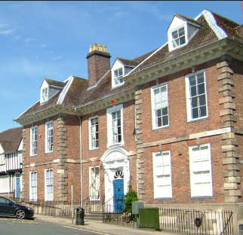

Warwick Town Council
The Court House, Jury Street, Warwick. CV34 4EW

01926 492212
