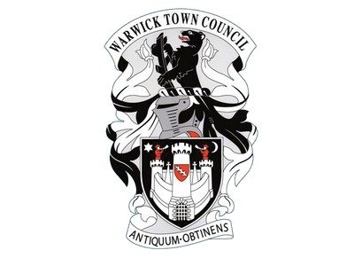

**Warwick Town Council**

**Newell Orton**

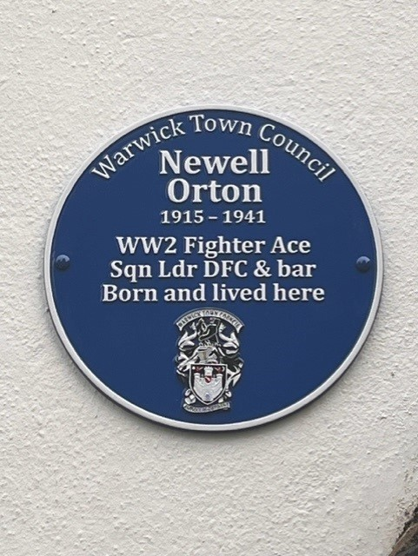

Newell Orton, DFC & Bar (1915 –1941)

Newell Orton was born in 1915 in Warwick. He was educated locally at Coten End School and Leamington Technical College

He learned to fly at the Royal Leamington Spa Flying Club. He joined the Royal Air Force Volunteer Reserve in 1935 and was soon a qualified pilot with the rank of sergeant. Two years later he received a short service commission in the Royal Air Force and was posted to No. 73 Squadron as a flying officer. On 24th August 1939, No. 73 Squadron was mobilised for war. On 8th September 1939, shortly after the start of the Second World War, it deployed to France. Towards the end of that year and into early 1940, poor weather meant little action was seen. Conditions began to improve into February and operations were more frequent thereafter. On 26th March Orton shot down two Messerschmitt fighters near Trier. A month later, he destroyed an enemy plane that attacked his flight while it was pursuing two other enemy fighters. Later, in the same patrol, he shot down another Messerschmitt, one of a group that intercepted his flight, and damaged another. Orton became a flying ace, credited with five German aircraft destroyed. In April 1940, his parents received a letter from then Foreign Secretary and local MP, Anthony Eden, which said: “I see from the newspapers that your son led three Hurricane fighters in a remarkable fight against twelve German machines the other day on the Western Front, I am writing to send you and him my heartiest congratulations on his very fine performance.”

On 15th May, Orton, flying with five other Hurricanes of his squadron, was wounded during a dogfight. Bailing out, Orton’s parachute was caught up in trees when he landed, and he had to be rescued by another RAF officer. His wounds required hospitalisation and ended his involvement in the Battle of France. By this time, he was credited with at least fifteen enemy aircraft destroyed. Two days later, he was awarded the Distinguished Flying Cross (DFC) for ‘exceptional gallantry’. Whilst at home recovering, Orton gave a talk to the Spitfire Fund Raising Committee, which was reported in the Warwick Advertiser. Orton was awarded a bar to the DFC on 16th July 1941 - the first of the Second World War for a No. 73 Squadron pilot. In September, he was promoted to flight lieutenant. Orton returned to action in July 1941, when he was posted to No. 242 Squadron. On 17th September, the squadron was involved in an engagement with around fifty enemy planes near Le Touquet. Orton was one of three pilots of the squadron who were shot down and killed. Survived by his wife Helen, Orton has no known grave and is commemorated on the Runnymede Memorial and on the war memorial in Church Street, Warwick. He is credited with seventeen aircraft destroyed, eight probably destroyed, and four damaged. Newell Orton’s prowess as a fighter pilot was well-known in Warwick and he was very highly regarded as a local hero.

Orton on the left with fellow no 73 squadron pilot Edward Kain

**Warwick Town Council**

The Court House, Jury Street, Warwick. CV34 4EW

01926 492212

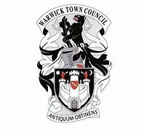

**Warwick Town Council**

The Court House, Jury Street, Warwick. CV34 4EW

01926 492212