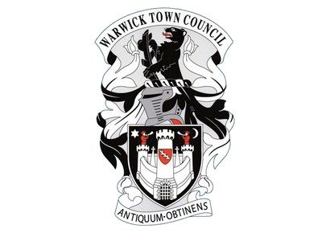
Warwick Town Council
Arthur Measures

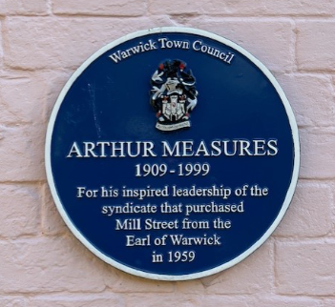
ARTHUR MEASURES
(1909-1999)
The blue plaque was awarded for his inspired leadership of the syndicate that purchased Mill Street from the Earl of Warwick in 1959.

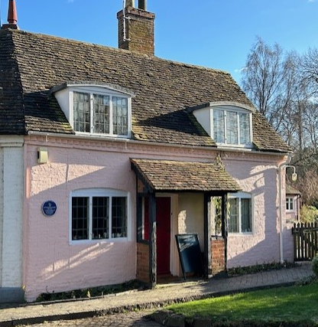

Arthur Measures was born in Manchester and at the age of one moved into the Warwick workhouse, his parents were the master and matron. It is here that he saw how easily poverty could tip people into destitution.
Arthur went on to become the manager of the main bank of Barclays Bank in Birmingham where he was well known for his kindness. It seems likely that this kindness stems from childhood experiences.
He married Violet Bray in 1936 who was a local Warwick woman and they moved into the cottage at the end of Mill Street where they made a cottage garden. The garden was originally opened for one weekend to raise money to restore St Mary’s church tower. However, Arthur and Violet went on to open their garden from Easter to October after acquiring other charities.
In 1959 residents in the Mill Street cottages discovered that their homes were about to be sold by the Earl of Warwick. The sale was a single lot, so the residents did not have a chance of bidding. Arthur organised a syndicate with a loan from Barclays and bought all the cottages for £610,000 and then divided up the leases. He then took early retirement from the bank.

Today The Mill Garden is a half-acre informal cottage garden and lies in a superb setting beneath the walls of Warwick Castle, beside the river Avon.
It is a garden of winding paths that lead through a delightful series of plantings with an abundance of plants, shrubs and trees.
Around every corner there are dramatic views of the castle, medieval bridge, castle mill and the river. It is a place of peace and beauty. Today it is run by Julia Measures, Arthur Measures’ daughter and her husband David Russell, the family has owned the gardens since 1938 with Arthur working on it for 60 years.
The remains of the old castle bridge are visible from the garden, the bridge once carried most of the traffic to Warwick over the River Avon.
When the castle was being constructed the garden was often used as a stonemason’s yard.
Today the garden is open to the public seven days a week from Easter to October, or by arrangement. Admission is just £3 per adult; it is free for accompanied children.

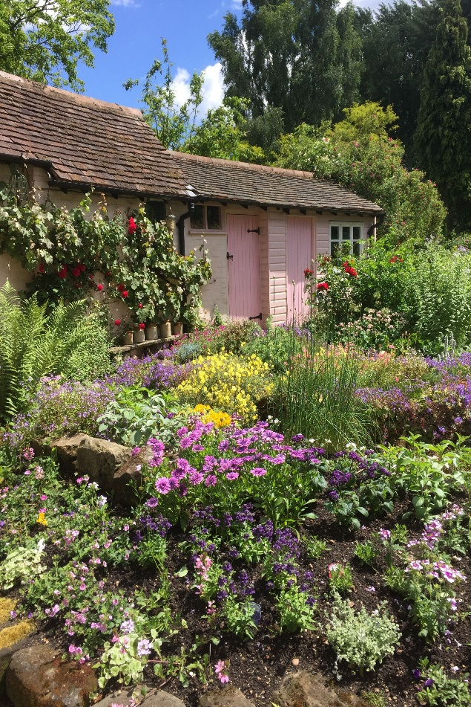

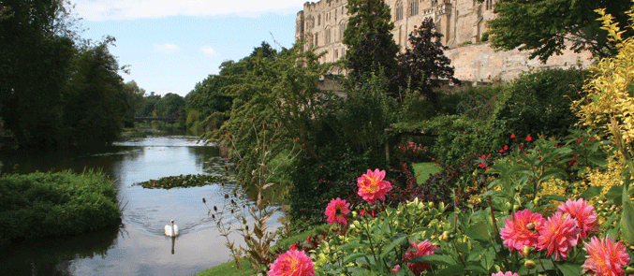
Warwick Town Council
The Court House, Jury Street, Warwick. CV34 4EW

01926 492212

