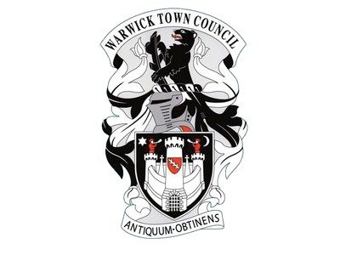
Warwick Town Council
King’s High School
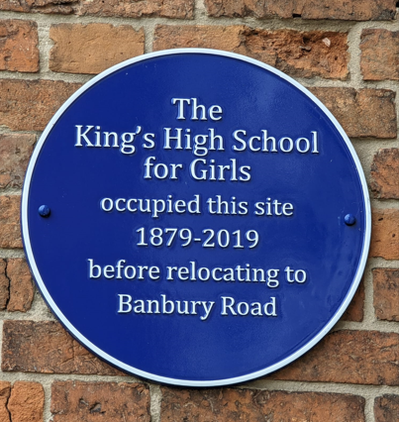

KING’S HIGH SCHOOL
1879-2019
King’s High School formerly occupied this site. The picture is of Landor House nestled near to the Eastgate at the top of Smith Street.
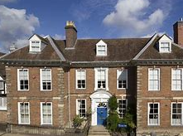

The King’s High School for girls opened its doors for the very first time in April 1879. Queen Victoria had reigned for forty-two years and Benjamin Disraeli was Prime Minister. 1879 was also the year that gave us milk in glass bottles and the first ever Blackpool illuminations.
It would be unthinkable today to appoint somebody without a university degree to lead an award-winning girls’ school, but King’s Highs’ first principal Miss Mary Janet Fisher did not have one. Miss Fisher was about as highly qualified for her post as a woman could have been in 1879; she held a Cambridge University Higher Certificate for Women. Miss Fisher was just 22 when she beat 70 other candidates for the post, which carried a salary of £100 per annum plus an extra pound for each girl in the school.
Two ground floor rooms of Eastgate House (Landor House) were classrooms with Miss Fisher and her staff using the upstairs rooms, including the head’s apartment. There were no dedicated rooms for subjects like Domestic Economy, Natural Sciences and Drawing and the music had to be limited to vocal only. However, less than a week before the school opened Miss Fisher managed to secure a piano for the girls costing £25.

an a week before the school opened Miss Fisher managed to secure a piano for the girls costing £25.

Miss Fisher and her assistant mistress, Miss Browning, presided over the school’s original 21 girls in East Gate House Hall. The list of scholar’s names recorded makes interesting reading. Delving into the backgrounds the girls were mainly the daughters of shopkeepers and clerks.
By the 1900s the girls were learning a variety of subjects and a trickle of sixth formers began to go to university.
By the 1920s under the charismatic leadership of linguist and author Miss Eleanor Doorly, the school introduced form and school councils, far sighted at the time.
With a huge programme of building work in the 1960s over 600 girls were educated on the Smith Street site and university entrance became more widely achieved.

During the first 14 years of the 21st century the school continued to flourish with Mrs Surber at the forefront. In 2015 Mr Nicholson joined King’s High School as its first headmaster. As well as leading the schools forward thinking approach to teaching and learning he also spearheaded the moved to the new state of art school on the Banbury Road in Warwick.

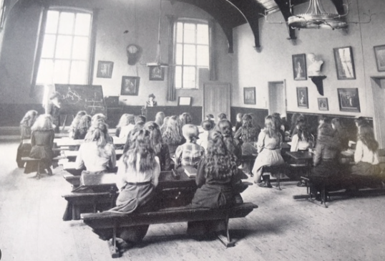

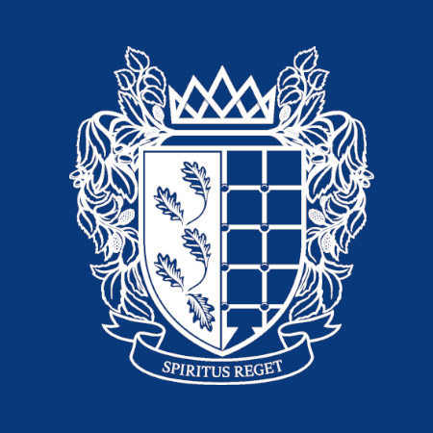

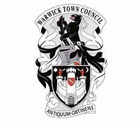
Warwick Town Council
The Court House, Jury Street, Warwick. CV34 4EW

01926 492212

