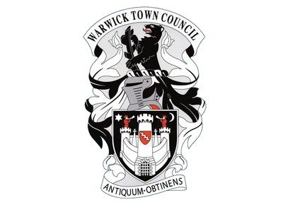
Warwick Town Council
J R R Tolkien and Edith Bratt

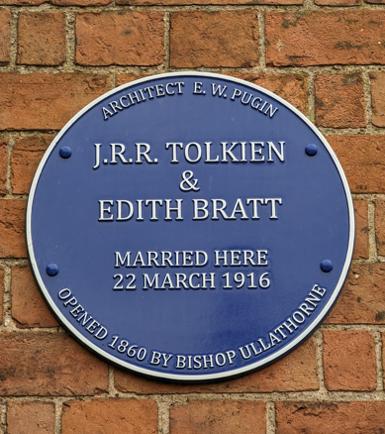
2405
J R R Tolkien (January 1892 – September 1973)
J R R Tolkien was an English writer and philologist. He was the author of The Hobbit and The Lord of the Rings.

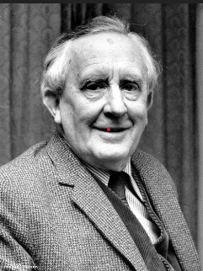

J R R Tolkien’s father was Arthur Reuel Tolkien and was an English bank manager who died of rheumatic fever. His mother Mabel’s family lived in Stirling Road in Birmingham where they owned a shop. Tolkien’s mother said his strengths were art, botany and languages, by the age of four he could also read and write fluently. The first language he taught himself was Naffarin.
Tolkien attended King Edward’s school in Birmingham and was one of several cadets who helped line the route for the coronation of King George V. He went on to Exeter College, Oxford, where he graduated with a first-class honours degree in English Language and Literature. Tolkien was influenced by his travels in Switzerland and its landscapes. This features heavily in Bilbo’s travels over the misty mountains in The Hobbit.
Tolkien was a devout Roman Catholic and in 1916 he married Edith Bratt after she had converted to Catholicism.

The wedding took place at The Roman Catholic Church of St Mary Immaculate, Warwick. Tolkien and Edith went on to have four children. Edith inspired the fictional character, Luthien Tinuviel.
Tolkien wrote The Hobbit (for his children), The Fellowship of the Ring and The Two Towers while living at 20 Northmoor Road in Oxford.
During World War II Tolkien was earmarked as a code breaker. Queen Elizabeth II gave him the Commander of the Order of the British Empire in 1972.
Sarehole Mill in Birmingham was of Tolkien’s favourite places. The Mill and the surrounding area would have influenced The Middle Earth he created in The Hobbit and The Lord of the Rings. When Tolkien illustrated his original books, he always drew the mill in Hobbiton with a little tower, just like Sarehole Mill.
Tolkien uses the two historical aspects of Warwick, the Anglo-Saxon and the post-Norman medieval as sources for two of the most clearly defined kingdoms of Middle-earth, Rohan and Gondor. They are neighbours and allies in the book, but their social, cultural and political situations clearly differentiated, illuminated through the history of Warwick.
Tolkien day is each year on January 3rd, which, is the commemoration of the birth of J.R.R. Tolkien. It celebrates his world-famous fantasy writings that have become part of mainstream culture.
J R R Tolkien died on 2nd September 1973 (aged 81). He is buried at Wolvercote Cemetery in Oxford.

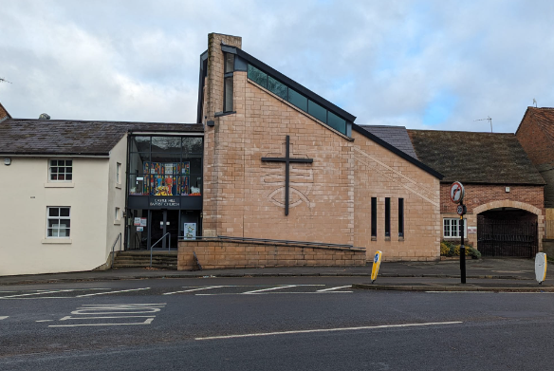

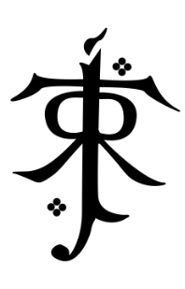

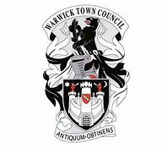
Warwick Town Council
The Court House, Jury Street, Warwick. CV34 4EW

01926 492212

