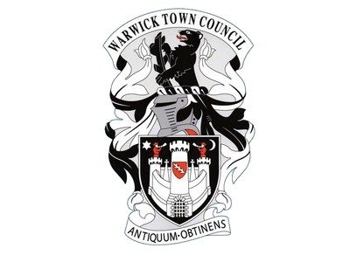
Warwick Town Council
Warwick Gas Works

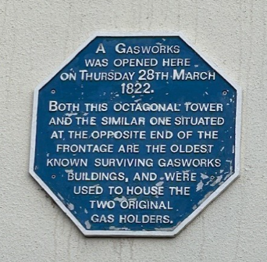

WARWICK GAS WORKS
One of the best preserved
gas works in the world.

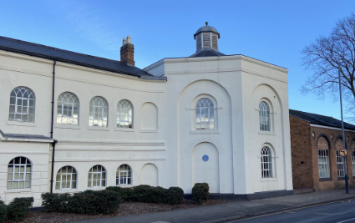

By 1851 the gas works comprised a central block with wings flanked by two octagonal gasometers. The gasometers, evidently dating from 1822 are treated architecturally as brick buildings. The central block contained the office, valve-house and ‘loder’ and gave access to a court in which stood a large retort. When rails superseded water for the transportation of coal a tramway joined the gas works.
The octagonal towers and the retort house to the rear is an example of the pattern used on many sites. The original gas holders which had a stone base are rare in Britain. In a 19th century explosion, the stone shattered so they were replaced for safety reasons. The replacement gas holders had no stone around them.
The works made town gas from coal. Apart from serving Warwick, the works ‘exported’ gas to Leamington to light the town and in 1823 the Warwick Gas Company erected 18 lamps along Union Parade, supplied from their Saltisford works by a three-mile main along the Myton and Old Warwick Roads.

In 1830 the oil lamps in Leamington’s parish church, were replaced by 19 gas lamps. A few years later Leamington got its own gas works on Tachbrook Road, providing gas to light the town from 1835.
Expansion of the gas works took place by 1851. By 1900 three large gasometers had been built, but by the late 20th century only the early octagonal gas holders remained. The gas works closed in the late 20th century.
The historic Saltisford Gas Works lay derelict for over 10 years before planning permission was granted for the building to be redeveloped as a block of 22 affordable homes in 2013. The £3.8million residential development by Waterloo Housing Group includes 22 flats, 13 of which, remain for rent only.

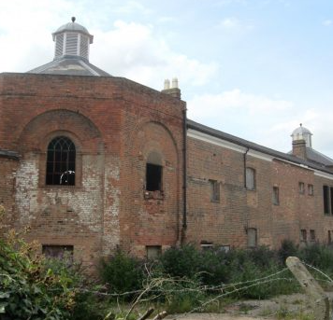

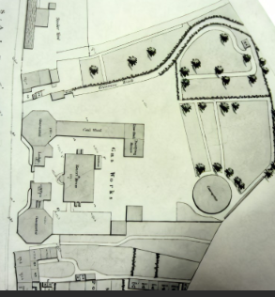

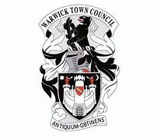
Warwick Town Council
The Court House, Jury Street, Warwick. CV34 4EW

01926 492212

