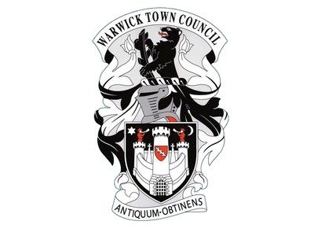
Warwick Town Council
Donald Healey
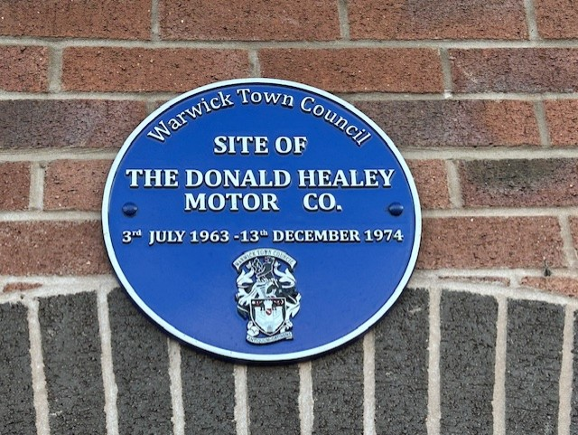

DONALD HEALEY
1898-1988
English car designer, rally driver and speed record holder.
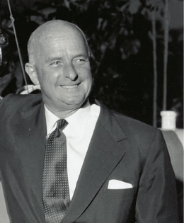

Donald Healey was born in Perranporth, Cornwall on 3rd July 1898. Healey was fascinated with all things mechanical from an early age and would go on to study engineering at Newquay College before taking up an apprenticeship with the Sopwith Aviation Company in Kingston Upon Thames. He then joined Sopwith in 1914 while continuing his studies at Kingston Technical College. Sopwith had a workshop at the nearby Brooklands aerodrome and racetrack circuit. Healey would leave his apprenticeship early to serve in the Royal Flying Corps in 1916 and gained his wings as a pilot.
In 1920 he opened a garage in Perranporth and in the same year he would marry his wife Ivy, they would go on to have three sons together. He would quickly become bored of his garage and began pursuing his interest in motor racing. He would routinely use his premises to prepare vehicles for competitions. As a result, Healey progressed into racing by winning the Brighton rally entering the Monte Carlo rally in 1929 and winning the latter two years later. By 1933, Healey had been snapped up by Triumph where, as technical director, he would go on to develop the Triumph Southern Cross and the Triumph Dolomite 8. He would continue to race in Triumph cars until the liquidation of the company in 1939.

Healey would, for the time being, stay at the Triumph site working as the works manager for H B Hobson, making aircraft carburettors for the Ministry of Supply. Later, he would work with Humber creating armoured vehicles for the military. In 1945 the Donald Healey Motor Company was founded along with Achille Samprieto and Ben Bowden.
Healey’s first car the Elliot rolled off the production line in 1946. The car that followed in 1949, the Silverstone, was so successful that it led to a partnership with American company Nash Motors. The agreement with Nash Motors established the Nash Healey sports car.
Donald began to focus on affordable cars. A joint venture with Austin saw the formation of Austin-Healey in 1952 and the first car the Austin-Healey 100 was revealed at the Earls Court Motor Show. On 3rd July 1963, on his 65th birthday, he opened a new plant in the Coten End area of Warwick, on the site of the old cinema, which was being used as a bingo hall at the time of acquisition. The new premises, which included a showroom, was opened by Alec Issigonis, the designer of the Mini.
On 15th January 1988 Healey passed away. A number of memorials were erected in his memory and the motoring legacy he had created. Thousands of cars still exist in museums or as part of the classic car societies today.

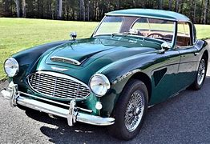

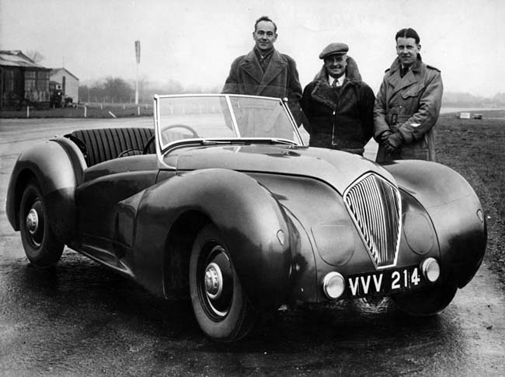

Warwick Town Council
The Court House, Jury Street, Warwick. CV34 4EW

01926 492212

