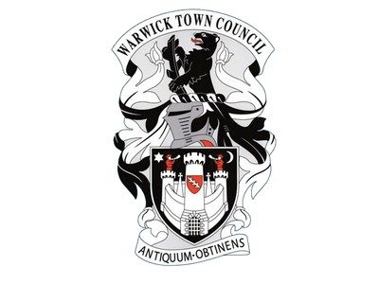
Warwick Town Council
Dick (Lionel) Turpin

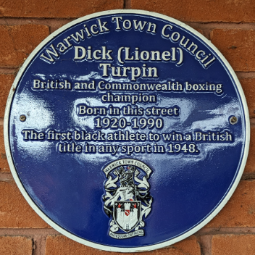

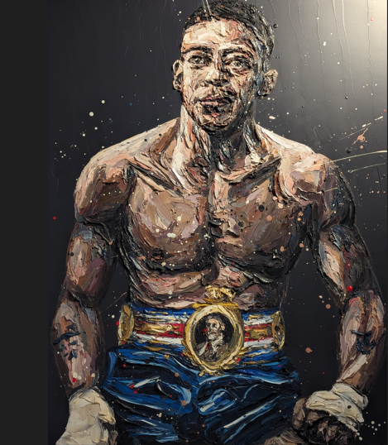

Dick was born in Warwick in the 1920s but also spent much of his life in the neighbouring town of Leamington Spa. His father Lionel Turpin was born in British Guyana, his mother Beatrice Elizabeth Whitehouse was born in Warwick. Dick’s father was black and his mother was white during a time before significant ethnic diversity in Britain.

Lionel senior died in 1925, he had never fully recovered from the injuries he sustained whilst fighting at the Battle of Somme. Beatrice was left to raise the children alone. Dick was the oldest of five children, followed by Joan, John (commonly known as Jackie), Kathleen and Randolph. Dick and his two younger brothers, Jack and Randolph, all took up boxing during childhood. Dick and Randolph were both middleweights, while Jack fought at featherweight. Dick was the first black athlete to win a British title after the Board of Control lifted the colour bar in 1948.

Dick went on to build up a domestic record of 86 flights with 68 wins, 12 losses, 5 draws and one no-contest, before his first title fight. This was for the Commonwealth middleweight title in May 1948, and was against Bos Murphy of New Zealand. Turpin won the fight at Coventry by a knockout in the first round to become Commonwealth champion.

DICK (LIONEL) TURPIN
(Noember 1920 – July 1990)

Dick (Lionel) Turpin was a British and Commonwealth middleweight champion

On 28 June 1948 Dick Turpin defeated Vince Hawkins, it was a gruelling 15-round battle in the pouring rain in front of 40,000 people at Villa Park, Birmingham.
During late 1948 and early 1949, Turpin fought European boxers. He drew and then lost on points against Tiberio Mitri of Italy. He was knocked out in seven rounds in a non-title fight against the then world middleweight champion, Marcel Cerdan of France. He then won by a disqualification against another Frenchman, Robert Charron.
In June 1949, he defended his British and Commonwealth titles against Albert Finch, winning on points after fifteen rounds.
In September 1949, he defended his Commonwealth title against Australian, Dave Sands. The fight was at Harringay Arena, and Turpin was knocked out in the first round, and so only retained his British title. Turpin then won his next four fights, losing the fifth, on points to the American, Baby Day, before defending his British title against Albert Finch, whom he had beaten in his previous defence. The fight was held in April 1950 in Nottingham and Finch won on points after fifteen rounds.
Having lost both his titles, Turpin had only two more fights, against the Belgian, Cyrille Delannoit, in Brussels, losing on a technical knockout in the sixth, and finally against his old rival Albert Finch, losing on a technical knockout in the eighth. This last fight was in July 1950.
Dick was buried at the Brunswick Street Cemetery, Leamington Spa. His funeral was paid for by the Leamington branch of the British Legion.
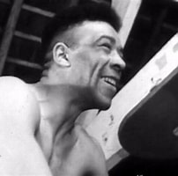

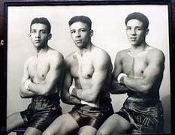
The Turpin Brothers

Warwick Town Council
The Court House, Jury Street, Warwick. CV34 4EW

01926 492212

