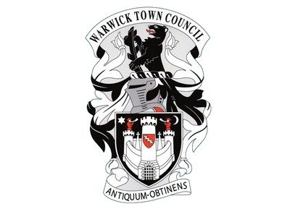
Warwick Town Council
Castle Hill Baptist Church

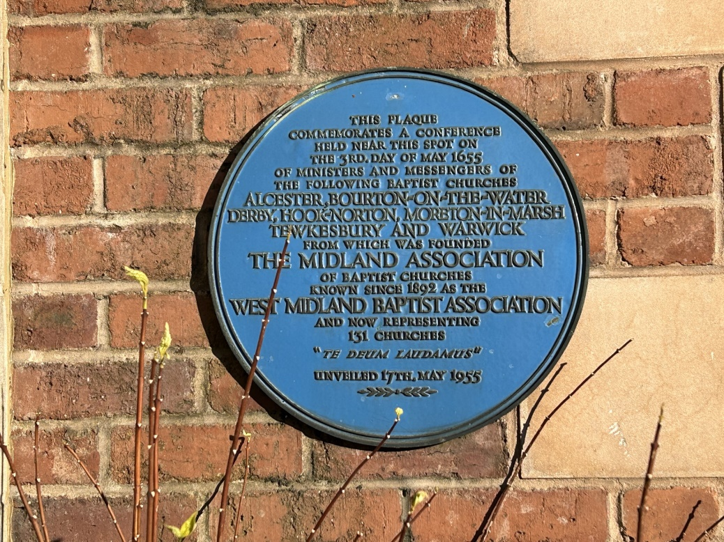

CASTLE HILL BAPTIST CHURCH
Its history can be traced back to 1649 and it is known that Baptists have worshipped on this site since 1685.
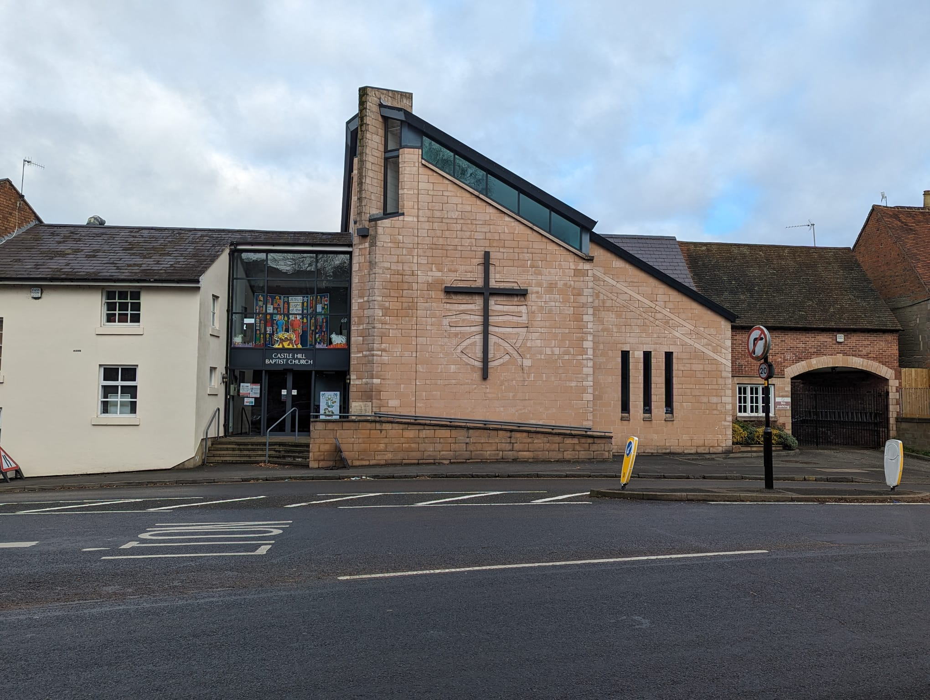

Castle Hill Baptist Church was founded in the 17th century when non-conformist churches were undergoing persecution in England, although Castle Hill itself escaped much persecution due to the protection offered by Lord Brooke of Warwick Castle.
Because of this threat, the church first met in private houses. In 1655 seven churches met and founded the now called Heart of England Baptist Association. In 1865 the church began meeting on the current site. It was given a garden plot to function as a cemetery due to restrictions on non-Anglican burials in the graveyards of parish churches. For the next 15 years the church continued to meet on this plot. By 1700 the first purpose-built church building was constructed on the site. The first church building only lasted 40 years and shortly afterwards John Cohen-Rylands became the minister of the church. Ryland’s son was a co-founder of the Baptist Missionary Society. Church membership was only open to those who were baptised and this did not change until 1930.

At the end of the 18th century the church began a Sunday school. By 1820 the church was near closure and only the effort of a deacon of the church saved it. A decade later an extension was necessary. In 1866 a much larger Gothic revival style church was built; this was in place for the next 120 years.
By the mid-20th century, the church building was causing serious concern. In the end a new church building was erected, this was a long project which began in 1970, the same year that the pub next door came onto the market, this was bought by the church together with the accompanying car park. The former pub saw use as general purpose church rooms, the church hall saw use for youth work. By 1986 the condition of the church had deteriorated and Sunday services were moved to the church hall in Gerrard Street.
In 1993 Warwick Town Council backed by English Heritage stated that the 1866 building must be preserved given its historic nature. The planning application for the new building was rejected. A revised planning application for the new building was approved in 1997. Funding for the estimated cost of £650,000 was raised through a combination of congregational giving, charitable grants and bank loans. It was completed a year later.
The church then saw a renaissance in its new building, holding many events including two Sunday services, a playgroup, toddlers’ group, prayer meetings and a youth group.

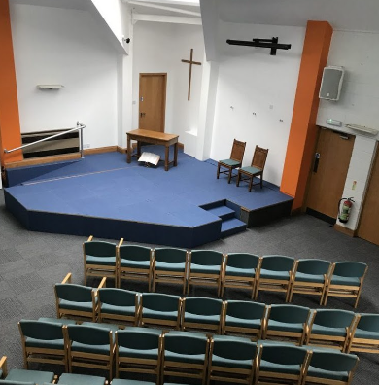

Warwick Town Council
The Court House, Jury Street, Warwick. CV34 4EW

01926 492212

