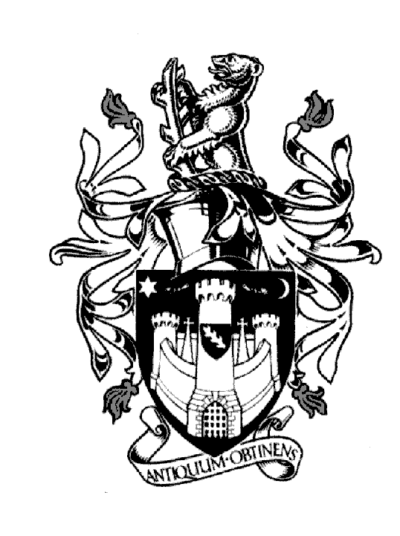
WARWICK TOWN COUNCIL

Court House
Jury Street
WARWICK
CV34 4EW
Tel: 01926 411694

Jayne Topham
Town Clerk

ANNUAL COUNCIL MEETING
TUESDAY 16th May 2023

MINUTES

- Welcome: The Mayor welcomed guests and new councillors. A standing ovation was made to the former councillors.

- Prayers - Rev J Hearn & Gianni Surjit Singh said prayers.

- Apologies: Cllr J Darcy and Cllr M Edwards submitted their apologies; it was resolved to accept them.

- Declarations of Interest: None

- Confirmation of minutes from the Council Meeting 30th March 2023- it was resolved to approve the minutes.

- To receive and adopt the minutes of the following committee meetings.

Allotments Committee held on the 5th April 2023
Community & Culture held on the 13th April 2023
Economic & Tourism held on the 27th April 2023
Finance & Policy held on the 2nd May 2023
Planning Committee held on the 20th April 2023
It was resolved to approve the minutes of all meetings listed.

- Approve polices – previously approved at Finance & Policy
- Complaints procedure
- Freedom Information requests
- Social media policy
It was resolved to approve the minutes of all policies listed.

- Grants: Citizens Advice £5k – approved at committee level - ratify
Parenting Project £5k – approved at committee level – ratify
It was resolved to approve both grants.

- Mayor Elect. confirm Cllr O Jacques. – It was resolved to approve.

- Deputy Mayor Elect. Confirm Cllr D Skinner - it was resolved to approve.

- Presentations Presentation to the Mayor’s Charities:
        - Lord Leycester hospital £1500.00
        - Heathcote Community centre ( Warwick Gates ) £500.00
        - Chase meadow community cente £500.00
        - KHALSA Hockey £750.00
        - Saltisford Canal trust £500.00
Mayor’s award : Presented to J Plumb and R Singh Hayer.
Presentation and thanks to Mayor Cadet Sgt R Astel-Kelly.
Presentation to Gianni Durjit Singh.
Presentation to Cllr M Ashford for 20 years as a Councillor.
Presentation to Terry Gardener for 25 years as Sergeant of Mace.

- Election of Town Mayor: Cllr PS Birdi proposed Cllr O Jacques to be Town Mayor 2023/4
This was seconded by Cllr D Skinner.

- Vote of thanks to retiring Town Mayor – Former Cllr N Butler led thanks to the outgoing Mayor Cllr PS Birdi. This was seconded by Cllr D Skinner.

- Appointment of Mayor’s Chaplin: Rev J Hearn was appointed and presented his Chaplin badge.

- Appointment of the Mayor’s Cadet: Able Cadet John Burston - Seacadet

- Election of Deputy Town Mayor: Cllr J Sullivan proposed Cllr D Skinner this was seconded by Cllr Ms K Dray.

- Appointment of Petty Officers: The Town Clerk confirmed that M Reddy would continue as Town Crier, T Gardener would remain as Sergeant of Mace and W Spraggett Assistant Sergeant of Mace.

- To confirm the membership of committees: The committees were approved as presented.

- To confirm the representation for outside bodies. The outside bodies were approved as presented.

Signed……………………………………….Dated……………………………….

