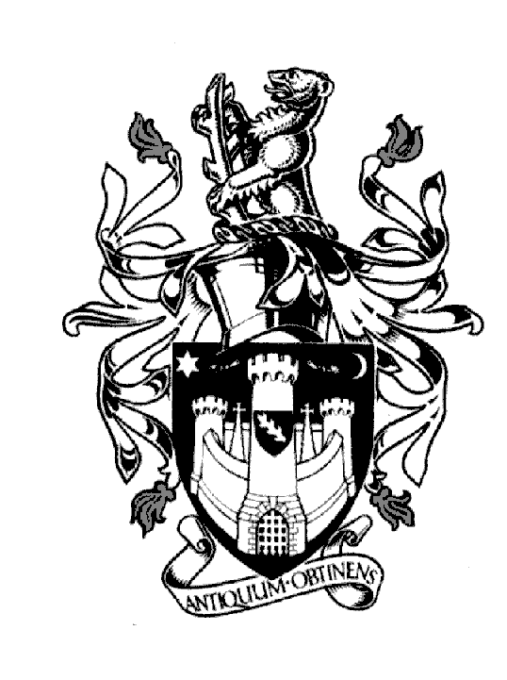
WARWICK TOWN COUNCIL

Court House
Jury Street
WARWICK
CV34 4EW
Tel: 01926 411694

Jayne Topham
Town Clerk

FULL COUNCIL MEETING

YOU ARE HEREBY SUMMONED to a Meeting of Warwick Town Council to be held in the Ballroom,
Court House, Jury Street, Warwick on THURSDAY 14th DECEMBER 2023 commencing at 6.30pm.

An Agenda is appended below:

The Court House Jayne Topham
Jury Street Town Clerk
Warwick

AGENDA

Section A Council

58. Prayers - Rev J Hearn

59. Apologies:

60. Declarations of Interest:

Members are reminded that they should declare the existence and nature of their
personal interests at the commencement of the relevant item (or as soon as the
interest becomes apparent). If that interest is a prejudicial interest, the Member
must withdraw from the room unless one of the exceptions applies.

61. Mayors Announcements

62. Confirmation of minutes from the Full Council Meeting 26th October 2023
(Minutes attached)

63. Reports to be received from District or County Councillors
(Reports attached)

64. Reports of Plans Committee
Planning Committee held on the 6th November & 7th December 2023
(Report attached)

65. To receive and adopt the minutes of the following committee meetings.
Allotments Committee held on the 27th November 2023
Community & Culture held on the 9th November 2023
Economic & Tourism held on the 16th November 2023
(Reports attached)

66. Chris Elliott CEO Warwick District Council to give an update on Warwick - Presentation &
Questions

67. To answer members’ questions

Section B General Purposes

68. Public Question Time

69. Plan Priorities – update Cllr D Skinner.

Jayne Topham

Town Clerk
7th December 23

