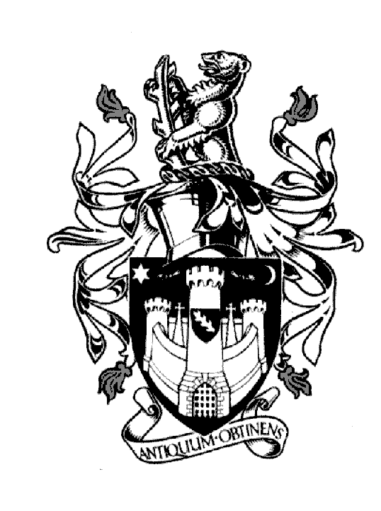
WARWICK TOWN COUNCIL

Court House
Jury Street
WARWICK
CV34 4EW
Tel: 01926 411694

Jayne Topham
Town Clerk

FULL COUNCIL MEETING

14th December 2023

MINUTES

Present:
The Mayor Cllr O Jacques
The Deputy Mayor Cllr D Skinner
Cllr J Darcy
Cllr Mrs K Dray,
Cllr Ms K Gorman
Cllr AP Murphy
Cllr S Pargeter
Cllr J Sinnott
Cllr J Sullivan
Cllr P Wightman

WCC: Cllr J Holland

WDC: Cllr D Harrison

Section A Council

58. Prayers - Rev J Hearn

59. Apologies: Cllr D Browne, Cllr M Edwards, Cllr Mrs E Harrison & Cllr Mrs M Mangat sent their
apologies, it was resolved to accept them.
WCC Cllr PS Birdi, WDC Cllr Ms H Yellapraga also sent their apologies.

60. Declarations of Interest: None

61. Mayors Announcements: The Mayor reviewed all the engagements he had attended since the
last Full Council meeting.

62. Confirmation of minutes from the Full Council Meeting 26th October 2023
It was resolved to approve the minutes as a true reflection.

63. Reports to be received from District or County Councillors
Reports were sent in advance of the meeting. Points were reviewed.
WCC Cllr J Holland advised that budgets were being reviewed and with rising costs concerns were
being raised to the point of S114 notices being considered.

WCC Cllr PS Birdi wished to bring the following consultation to the attention of Councillors.
Warwickshire Fire and Rescue Service - Consultation on proposed service delivery model - Warwickshire County Council - Citizen Space

The consultation on Warwickshire Fire & Rescue reconfiguration is going to consultation from
11th December 2023 till 10th March 2024.

Cllr Ms H Yellapraga WDC also wanted Councillors to know that action was being taken by Myton School about parking & traffic issues. They are liaising with Lidl who will allow parents to park and encourage students to walk to school.

64. Reports of Plans Committee
Planning Committee held on the 6th November & 7th December 2023

It was resolved to approve the minutes of both meetings.

65. To receive and adopt the minutes of the following committee meetings.
Allotments Committee held on the 27th November 2023
Community & Culture held on the 9th November 2023
Economic & Tourism held on the 16th November 2023

It was resolved to approve the minutes of all three meetings.

66. Chris Elliott CEO Warwick District Council to give an update on Warwick - Presentation &
Questions (Presentation attached Appendix 1 WDC strategy How do we make Warwick District
and great place to live)
A comprehensive presentation covering the main projects in Warwick – allowing Councillors to
gain clarification on timescales and understand WDCs involvement with ongoing issues with
empty shops and promotion.

67. To answer members’ questions
None.

Section B General Purposes

68. Public Question Time
Three questions were raised by members of the public – each question related to WDC
responsibilities.

69. Plan Priorities – Cllr D Skinner updated Councillors. The Town Clerk advised that following a
meeting with Cllr Mrs E Harrison and Cllr M Edwards, who raised concerns about the rivers in
Warwick, Seven Trent will be attending Full Council in March to update Councillors on project
progress Bathing Rivers.

Signed……………………………………. Dated ……………………………………

