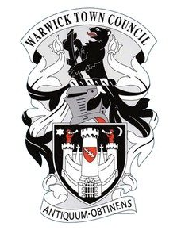
International Eurocamp in Verden, Germany
Saturday 20th July 2024 – Friday 2nd August 2024
Application Form
Completed forms to be returned to George Palmer, Warwick Town Council, Court House, Jury Street, Warwick. CV34 4EW or by email to George.Palmer@warwicktowncouncil.org.uk
Young Person  Name:_______________________________  Gender:______________________________  Age/D.O.B: ___________________________  Address: _____________________________  ____________________________________  ____________________________________  Post Code: ___________________________  Email: _______________________________  Tel No: ______________________________  Mobile:______________________________  Passport Number:_____________________  Passport Expiry Date:___________________  How did you hear about Eurocamp? | Supporting sponsor i.e. School  Name: ______________________________  Position: ____________________________  Sponsor: ____________________________  ____________________________________  Address: ____________________________  ____________________________________  ____________________________________  Post Code: ___________________________  Email: _______________________________  Contact No: __________________________
Aims of the Euro Camp
To bring together young adults, from a variety of backgrounds, and involve them in an international project.

Participants attending will need to be:
- Aged 16 - 21 and live in the Town of Warwick CV34 area
- Able to participate in a range of activities
- Interested or are already involved in volunteering leadership opportunities
- Willing to take part in community based projects and a range of team building activities with young people who are new to them
Outcomes for participants
- The chance to meet different people from different countries
- A chance to have fun and meet new people
- Increase skills in communication and working with others
- Increase confidence and leadership skills

Section for applicant to complete:
Please use the space below to tell us why you would like to take part in this project?

I am interested in taking part in Verden’s Eurocamp 2024 and agree to all of the above information being kept on file for the purpose of this event.

Applicants signature:______________________________ Date___________________

Section for sponsor to complete
Please use this space to tell us why you think the applicant named above would benefit from involvement in this project?

I fully support the applicant in taking part in the Verden 2024 Eurocamp and agree to all of the above information being kept on file for the purpose of this event

Sponsors Signature: ______________________________ Date___________________

