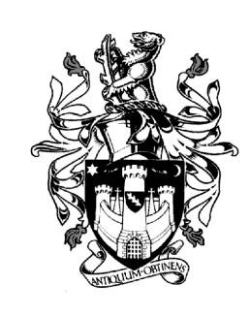
WARWICK TOWN COUNCIL

Court House
Jury Street
WARWICK
CV34 4EW
Tel: 01926 411694
Jayne Topham
Town Clerk

COMMUNITY & CULTURE COMMITTEE

9th NOVEMBER 2023

Present:
Councillor Mrs K Dray
Councillor Ms E Harrison
Councillor O Jacques (Sub)
Councillor S Pargeter (Chair)
Councillor J Sinnott
Councillor D Skinner (Sub)

Co-opted Members:
Unlocking Warwick Chair David Kelham, Bernadette Allen WDC

MINUTES

27. Apologies: Councillor D Browne, Councillor J Darcy, Councillor J Sullivan,
and Councillor P Wightman sent their apologies – it was resolved to approve the
apologies as stated.

28. Declarations of Personal and Prejudicial Interests. None

29. Matters Arising from previous minutes. None

30. Community Update - Report from Mrs B Allen WDC attached for reference.
Bernie advised that a site visit had been organised for the Parkmore’s community
centre and that the next meeting was scheduled for January 2024. Fusilier’s Way was
officially being opened on the 22nd June 2024. Questions were asked about the
Community Pantry. Bernie will send details to the Town Clerk for her to circulate.

31. Community Engagement
Unlocking Warwick – Chair D Kelham reviewed a report (attached)

32. Children Centre – Councillor Mrs E Harrison advised that the meeting was postponed
she will issue minutes to the Town Clerk for circulation.

33. St Mary’s Lands Working Party – Cllr P Wightman was absent therefore this item was
deferred.

34. Warwick Singing for Health – Jeremy Dibb gave an overview of his organisation and
forthcoming events.
(Newsletter attached)

35. St Nicolas Park CCTV – Martin Riley CCTV Operations Team Leader – this item was
deferred as the officer was not able to attend.

36. Blue Plaque application – William Holland
Councillors reviewed the application, and it was unanimously approved. A request was
made for the stain glass window at St Mary’s to be featured in the brochure and that the
blue plaque trail be linked to the Town Council website and the Tourist Information
Centre website.

37. Grants:
Hill Close Gardens - £2,988.70 – Chris Begg from Hill Close Gardens attended the
meeting. He gave Councillors an overview of the history of the gardens.
Councillors approved the grant unanimously.

38. Warwick in Bloom – Bus station – the proposal was reviewed, and the Town Clerk
advised that the cost had reduced making the overall cost £768.
Councillors approved the proposal unanimously.

Signed……………………………………… Dated…………………………………………….

