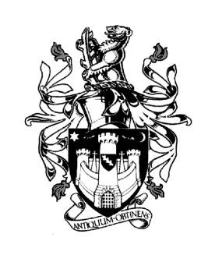
WARWICK TOWN COUNCIL

Court House
Jury Street
WARWICK
CV34 4EW
Tel: 01926 411694
Jayne Topham
Town Clerk

COMMUNITY & CULTURE COMMITTEE

NOTICE IS HEREBY GIVEN a meeting of the COMMUNITY & CULTURAL COMMITTEE of WARWICK TOWN COUNCIL will be held in the Council Chamber, Court House, Jury Street, Warwick on THURSDAY 9th NOVEMBER 2023 commencing at 6.30pm

Committee Membership:
Councillor D Browne (Chair) Councillor J Darcy
Councillor K Dray Councillor Ms E Harrison
Councillor S Pargeter Councillor J Sinnott
Councillor J Sullivan Councillor P Wightman
The Mayor (Ex Officio)

Co-opted Members:
Unlocking Warwick, Bernadette Allen WDC

AGENDA

27. Apologies

28. Declarations of Personal and Prejudicial Interests.
Members are reminded that they should declare the existence and nature of their
personal interests at the commencement of the relevant item (or as soon as the interest
becomes apparent). If that interest is a prejudicial interest, the Member must withdraw
from the room unless one of the exceptions applies.

29. Matters Arising from previous minutes. (Copy attached)

30. Community Update - Report from Mrs B Allen WDC
(Report attached)

31. Community Engagement
Unlocking Warwick – Chair D Kelham

32. Children Centre – update from Councillor Mrs E Harrison

33. St Mary’s Lands Working Party – update Cllr P Wightman

34. Warwick Singing for Health – Jeremy Dibb update
(newsletter attached)

35. St Nicolas Park CCTV – Martin Riley CCTV Operations Team Leader - update

36. Blue Plaque application – William Holland
(Proposal attached)

37. Grants:
Hill Close Gardens - £2,988.70

38. Warwick in Bloom – Bus station – approve proposal
(Proposal attached)

Jayne Topham

Town Clerk
2nd November2023

