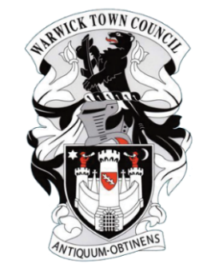

Warwick Town Council
Terms of Reference – Community & Culture Committee
The Community & Culture Committee is a standing committee of Warwick Town Council
and will operate in accordance with the Council’s Standing Orders and current legislation.

- Membership & Voting

- The Community & Culture Committee will be comprised of eight elected Members of the Council.
- The Community & Culture Committee may co-opt up to four representatives.
- All elected Members will be appointed to this Committee at the Annual Meeting of the Council.
- The Mayor will have automatic membership a Ex Offico and cannot vote.
- All other elected Members of the Council have the right to attend the meetings and make representations but cannot vote unless they are acting as “sub”.
- The Chair and Deputy Chair of the Committee will be elected at the first meeting of this Committee each Council year by the elected Members who sit on the Committee.

- Purpose of the Committee

The Community & Culture Committee will undertake management of all aspects of the Warwick in Bloom project and Twinning. They are involved with any community or culture events or projects.

- Aims and Objectives

The role of the Committee is to oversee the general management of Community events or projects held in the Town.
The Committee will:
- Liaise with other organisations in the Town, Warwick District Council/Warwickshire County Council officers when necessary.
- Review annually these Terms of Reference for approval at the Annual Meeting of the Council
- Seek quotes for all works where appropriate and in line with the Council’s Financial Regulations and Standing Orders
- To approve community grants to the value of £3k, above that figure grants have to be approved at Full Council.

- Meeting Arrangements and Frequency

- The C & C Committee will meet a minimum of five times a year with meetings scheduled at the beginning of the calendar year in question.
- Each meeting must be quorate before going ahead (minimum of three councillors to be present)
- In the absence of the Chair and the Deputy Chair, an elected Member must be elected to chair the meeting.
- The WIB awards evening will be held annually and all elected Members, Committee members will be invited to attend.

- Reporting and Accountability
As a Standing Committee of Warwick Town Council, the C & C Committee will publish minutes of its meetings on the Council’s website. The Committee will refer matters to the Council which are outside its Terms of Reference together with any recommendations.
Members of the public have the right of public participation at meetings of this Committee as set out in the Council’s Standing Orders and in line with the Council’s Guidance on Public Speaking at Council Meetings: https://www.warwicktowncouncil.gov.uk/wp-content/uploads/Public-Speaking-2020.pdf
- Urgent Matters
The Committee will provide two elected Members (normally the Chair and the Deputy Chair) to be consulted by the Town Clerk to deal with urgent matters which may have a legal or financial implication for the Council and time restraints prevent the normal arrangement of a Council or Committee meeting.

