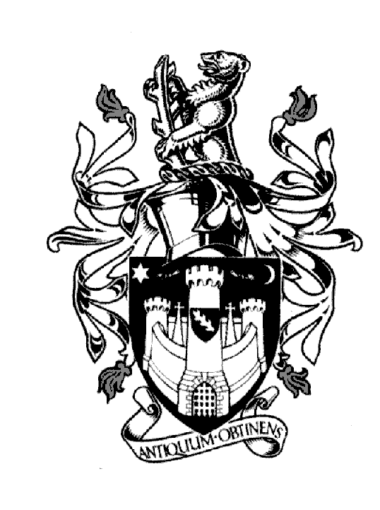
WARWICK TOWN COUNCIL
Court House
Jury Street
WARWICK
CV34 4EW
Tel: 01926 411694

Jayne Topham
Town Clerk
LOCAL GOVERNMENT ACT 1972
NOTICE OF ANNUAL TOWN MEETING

NOTICE IS HEREBY GIVEN that the Annual Meeting of Warwick Town Council
will be held in the Ballroom, The Court House, Jury Street, Warwick
on MONDAY 3rd APRIL 2023 commencing at 6.00pm.
The Meeting is open to the public.

AGENDA

- To receive apologies

- Minutes of the Meeting held on 6th April 2022

3. To receive and adopt the Annual Report of the Mayor

- To receive reports from County, District & Town Councillors/representatives

- To receive the reports of the Council Representatives on Local Charities

- To receive reports from local organisations and authorities

- To receive reports from local organisations including Community Grant beneficiaries

- To receive questions from Warwick residents

The Mayor invites all in attendance to remain for light refreshments following the meeting

Issued from the Mayor of Warwick, Councillor Parminder Singh Birdi, this date 27th March 2023

