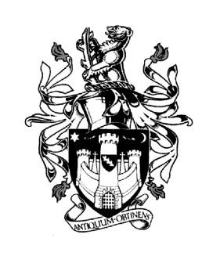
WARWICK TOWN COUNCIL

Court House
Jury Street
WARWICK
CV34 4EW
Tel: 01926 411694
Jayne Topham
Town Clerk

WARWICK TOWN COUNCIL

ALLOTMENTS AGM

MONDAY 4th SEPTEMBER 2023

MINUTES

- Opening of the meeting – The Chair of the Allotments Committee, Councillor John Sullivan, opened the meeting by welcoming everyone, thanking them for attending. He then introduced the Town Clerk and the next item on the Agenda.

- Financial Reports – The Town Clerk reviewed the accounts as provided, giving background to the figures. There were no queries.

- Allotments Awards Presentation – The Assistant Town Clerk led this item with a presentation outlining how the allotments judging works, thanking the judge and announcing this year’s winners. Trophies and certificates were presented by the Deputy Mayor, Councillor Dave Skinner, supported by the Town Clerk. Photographs of all the winners were taken.

- Update from the Allotments – a brief update report on the allotments was given by the Assistant Town Clerk. This was followed by a brief musical video from an allotment enthusiast to end this item.

- Members Questions – no questions were raised.

- Close – Councillor John Sullivan closed the meeting and thanked everyone present for their efforts, involvement and achievements in the allotments since this time last year.

Signed……………………………………. Dated………………………………………

