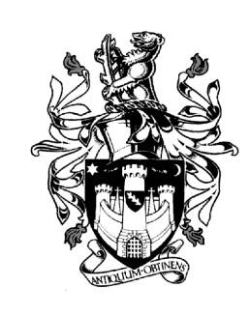
WARWICK TOWN COUNCIL

Court House
Jury Street
WARWICK
CV34 4EW
Tel: 01926 411694
Jayne Topham
Town Clerk

WARWICK TOWN COUNCIL

ALLOTMENTS A.G.M.

MONDAY 4th SEPTEMBER 2023

7pm, THE BALLROOM, THE COURT HOUSE, WARWICK

1. Opening of the meeting

2. Financial Reports (see attached) – Jayne Topham, Town Clerk

3. Allotments Awards Presentation – Katherine Geddes, Assistant Town Clerk

4. Update from the Allotments – Katherine Geddes, Assistant Town Clerk

5. Members questions

6. Close

Katherine Geddes Assistant Town Clerk 29th August 2023

