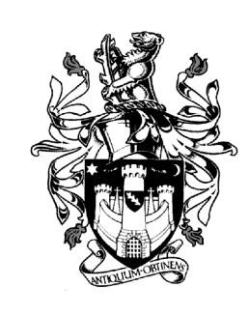
WARWICK TOWN COUNCIL

Court House
Jury Street
WARWICK
CV34 4EW
Tel: 01926 411694
Jayne Topham
Town Clerk

ALLOTMENTS COMMITTEE MEETING

NOTICE IS HEREBY GIVEN a meeting of the ALLOTMENTS COMMITTEE of WARWICK TOWN COUNCIL will be held in the Council Chamber, Court House, Warwick CV34 4EW on

MONDAY 4th SEPTEMBER 2023 at 6:30pm

Committee Membership:
Councillor Katya Dray
Councillor Eva Harrison
Councillor Raj Kang
Councillor Mini Kaur Mangat
Councillor John Sullivan
Councillor Paul Wightman

Mrs Katherine Geddes – Allotment Administration.

Co-opted Members:
Mr P Atkinson (Cape Housing West), Mr C Wiggins (Railwayside), Simon Wilson (Canalside) Phil Borrill – (PEAS), D MacLeod (Myton Green), Peter Lamb (WHS)

AGENDA

- Apologies

- Declarations of Personal and Prejudicial Interests.
Members are reminded that they should declare the existence and nature of
their personal interests at the commencement of the relevant item (or as soon as
the interest becomes apparent). If that interest is a prejudicial interest, the
Member must withdraw from the room unless one of the exceptions applies.

- Update from Allotment Administration Team - Mrs Katherine Geddes
(Report attached.)

- Site Reports - Allotment Representatives are requested to notify the office of
any maintenance issues in advance of the meeting.

- Terms of Reference – to discuss and agree the Terms of Reference for this Committee.

Katherine Geddes
Assistant Town Clerk
29th August 2023

