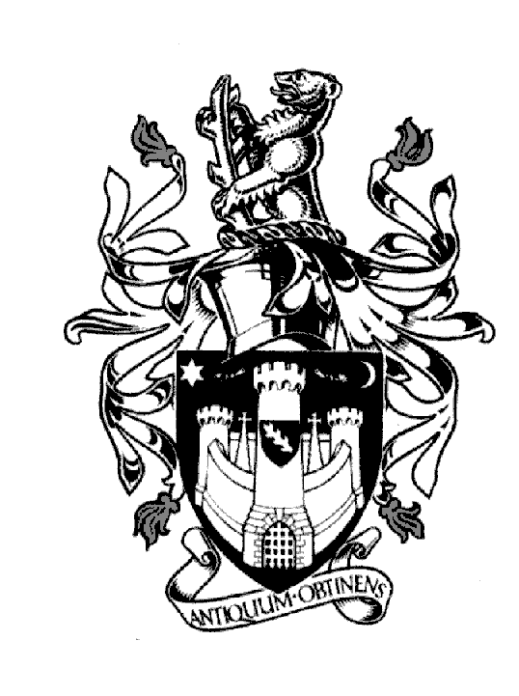
WARWICK TOWN COUNCIL

Court House
Jury Street
WARWICK
CV34 4EW
Tel: 01926 411694

Jayne Topham
Town Clerk

A SPECIAL MEETING OF THE COUNCIL

YOU ARE HEREBY SUMMONED to a meeting of Warwick Town Council to be held in the Council Chamber on Thursday 25th JANUARY 2024 commencing at 6.30pm.

AGENDA

70. Apologies

71. Declarations of Interest

72. Approve minutes of Full Council meeting 14th December 2023
(document attached)

73. Reports of committees
To receive and adopt the report from the Planning Committee meeting 11th January 2024.
(document attached)
To receive and adopt the report from the Finance and Policy committee 18th January 2024.
(document attached)

74. Estimates & Precept 2024/2025 – agree budgets and determine precept requirements – Cllr AP Murphy
proposing. (document attached)

75. Calendar of meetings 2024/2025 – Town Clerk - approve
(document attached)

76. Investment Policy – Cllr AP Murphy - approve
(document attached)

77. Reserve Policy – Cllr AP Murphy - approve
(document attached)

78. Risk Management – Cllr J Sinnott - approve
(document attached)

79. Recording Policy - Cllr D Skinner approve
(document attached)

80. CCLA – further investment of £300K into the Public Sector Deposit Fund – Cllr AP Murphy - approve.

81. Myton Green Allotment site – self managed lease – Town Clerk – approve.
(document attached)

82. Committee changes – Cllr Ms Cora- Laine Moynihan - add to Allotments and Community & Culture.
Cllr Paul Wightman - remove from Community & Culture. Town Clerk - approve.

Jayne Topham Town Clerk 18.1.24

