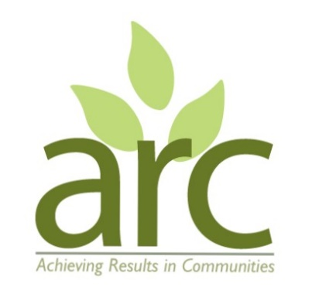
Improvements to land next to Packmores Community Garden

Report by ARC – Achieving Results in Communities
www.arccic.co.uk

Background and aims of the project

BACKGROUND
- ARC have been delivering Wellbeing sessions at Packmores Community Garden in Warwick since October 2022 with 6 to 12 participants each week.
- We are maintaining the community garden and are now working on an adjacent neglected site to improve it for wildlife.
- The boundary fence was completely broken and the boundary hedge depleted.

AIMS
- To improve the overall look of the area by clearing litter and old fence.
- To enrich the biodiversity to this area by reinstating and restocking the existing native hedge to the 45 linear meters of the boundary.
- To install a chestnut paling fence to replace the existing one, continuing the fence which goes along the adjacent community garden, protecting the growing hedge plants and deterring future littering.

The site before work began – in summer 2022
The visible vegetation is on the site. There is a ditch alongside the vegetation and the hedge and fence would go on the side nearer to the path.
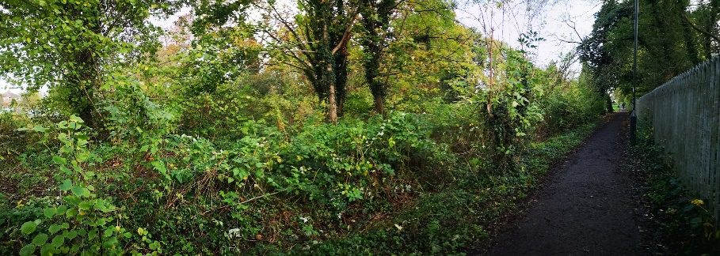

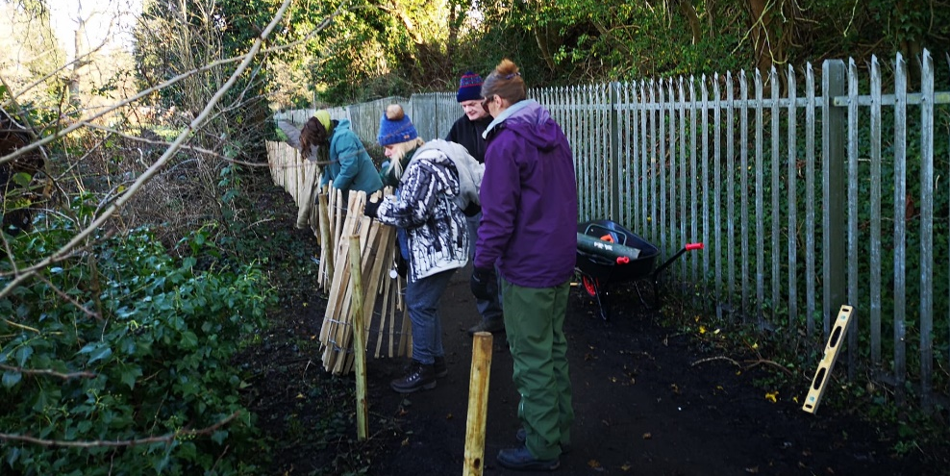
Work in progress on the fence

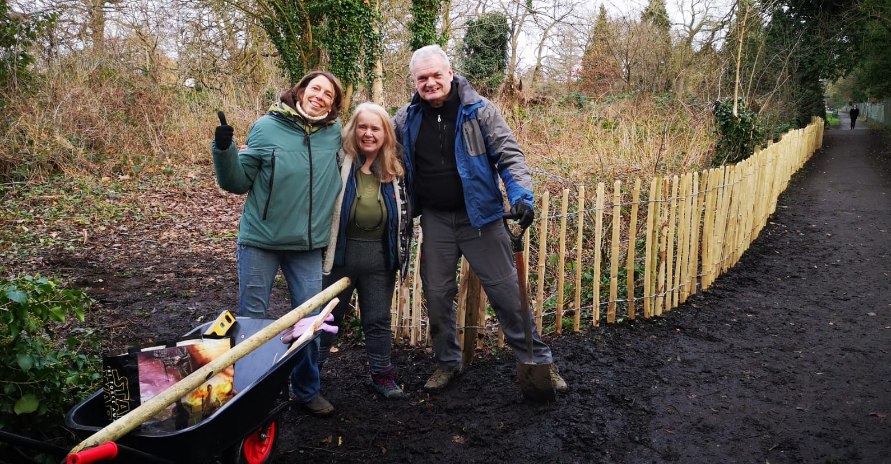
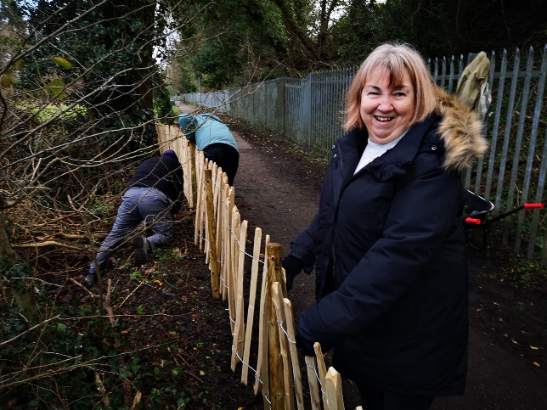

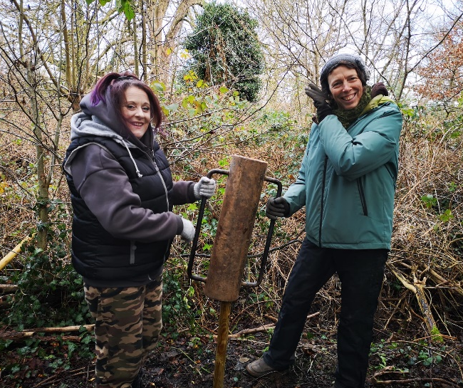

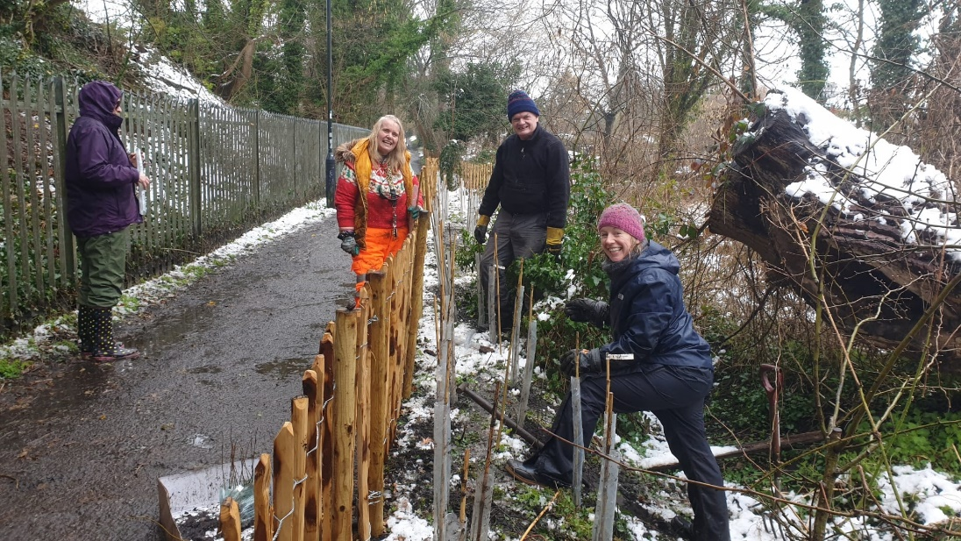
Finally we planted the hedge… in the snow!

Feedback from Participants involved
“I have enjoyed being involved in the whole process, especially because in these winter months and now spring myself and I'm sure other people get quite low at these times. Being part of a team to actually be proactive and building and planting and seeing results from the hard work done by all has made this year a better start for me.” CW
“A sense of achievement reclaiming the land for future use and community spirit in nature.” JW
“Putting the posts in for the fencing was great fun slamming [the post rammer] down with my and garden partner lifting it up with side handles. Such great team work, with people checking that it was straight. It was a great sense of achievement and I took my friend with me to the park the following weekend to show him what we had done. It was beautiful planting the trees for future and present people to enjoy. Serving our community, proud to have such a beautiful park on my doorstep.” AH
“I learnt about safety and the dangers lurking in old fences...rusty nails, barbed wire, things giving way etc, and looking at the ground underneath to make sure it is firm before you start pulling things around. I guess this is about assessing potential hazards at each stage rather than just wading in.” SF
“Great work all of you! I have seen foxes around this site. It is good you have left it open so they can pass through. This will also improve security for the allotments.” – A passer by

Budget
We completed the work under budget as we were able to obtain the trees for free from the Woodland Trust’s community planting scheme. We additionally purchased some small hand tools as we had insufficient for group planting activity.
ITEM | PROPOSED COST | ACTUAL COST
Chestnut paling, fence posts + fixings to secure southern boundary (40m) | £476.87 | £422.02
Hedging saplings + growing medium (40 linear meters + 5 meters for exposed allotment boundary) | £224.38 | £58.95
Delivery charges | £35.00 | £0 (some under item 1)
TOTAL | £736.25 | £480.97

