In 2022 Warwick Town Council installed more Christmas lights in Warwick Town Centre than ever before. Our Victorian Evening and Christmas lights switch on was attended by over 6,000 residents and visitors to Warwick on Thursday 24th November 2022. Our Christmas light displays are a perfect opportunity for visitors to come into Warwick and support our town centre and local economy. During these challenging times it also brings happiness and joy to people in Warwick; whether they work, live, or visit Warwick over the Christmas period.
With thanks to sponsorships, this year new lights will be installed at: Westgate House, Bus Station, Taxi Rank and Old Square.
Christmas 2024
Since promoting the installation of this year’s Christmas Lights and sponsorship opportunities available, several businesses have been in touch via social media to enquire and sign up to our sponsorship packages. In return, these businesses will be promoted as offical sponsorsrs of Christmas 2023 (however, businesses know that not all of this money received will be spent this year due to the short notice of signing up)

New feature for Christmas 2024 proposed (4m tall tree and 4 x 2.5m Archways). This will be a great opportunity for residents and visitors to stand under and have their photos; we will encourage people to share these on social media and tag our their location; which will promote Warwick as a destination to visit.
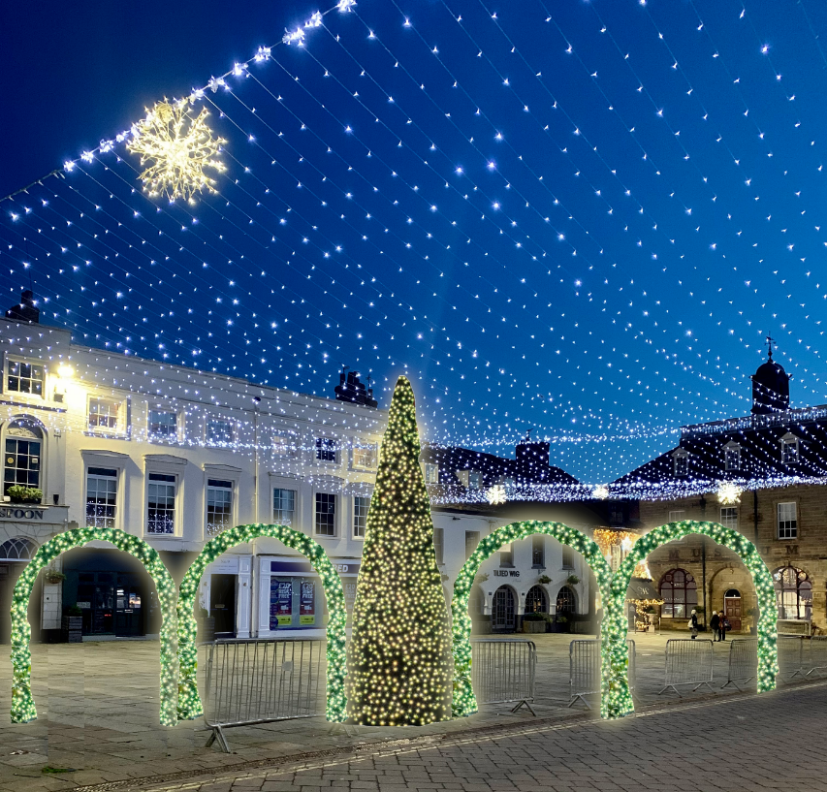

Cost of project (excluding VAT)
 | Supplier | Cost
4m Xmas Tree | Festive Lights | £2,999.99
Xmas Tree – Large Transformer | Festive Lights | £46.66
4 X Archways | Festive Lights | £3,066.64 (£766.66 Each)
4 X Archways – Large Transformer | Festive Lights | £186.64 (£46.66 Each)
Installation of Tree & 4 Archways | NS Booth | £3,155.00

Total To Purchase: £6,299.93

Annual Cost To Install, Remove & Store (NS Booth Electrical): £3,155.00

Estimated costs to spend on sponsorship (banners for The Court House, railing covers for town centre to promote sponsors & designers time): £500

Total cost for Christmas 2024 (purchase lights, install & promotional material) - £9,954

Income:
Budget remaining of £10,000 approved in February 2023 for new lights | £1,502.80
2023 sponsorship money remaining to be spent for Christmas 2024 | £1,182.44
2024 sponsorship money to be spent for Christmas 2024 (committed) | £2,900.00
Total £5,585.24

Proposal: approve proposal to install these new lights in Warwick Town Centre. Approve to purchase these in warm white to make a feature under the curtain of lights (which is cool white). Approve the above £5,585.24 will be used towards this project. Approve sponsorship letter (below) which will be sent to businesses to obtain the current short-full of funding.
Once Warwick has a new Christmas feature and builds a reputation for offering good value for money sponsorship packages each year, we are hopeful that we can continue to expand our sponsorship opportunities to businesses and organisations within Warwick and the surrounding areas; to generate further income.

WARWICK TOWN COUNCIL

The Court House
Jury Street
Warwick
CV34 4EW
Tel: 01926 411694

(Date)
Dear (Business/Organisation Name),
This year Warwick Town Council installed more Christmas lights in Warwick Town Centre than ever before. Our Victorian Evening and Christmas lights switch on was attended by over (TBC) residents and visitors to Warwick on Thursday 23rd November 2023.
Our Christmas light displays are a perfect opportunity for visitors to come into Warwick and support our town centre and local economy. During these challenging times it also brings happiness and joy to people in Warwick; whether they work, live, or visit Warwick over the Christmas period.
Our preparations are now underway for Christmas 2024, and we are writing to enquire whether you would like to become an official sponsor for our Christmas lights. We are inviting successful, local businesses to become an official partner and in return you will receive:
- Promotion on Warwick Town Council’s website throughout November and December.
- Coverage across all our social media platforms including The Mayor of Warwick, Warwick Town Council and Warwick Visitor Centre.
- Recognition in local and national press correspondence.
- Your business logo on our official sponsor posters in Warwick Town Centre for the duration of our Christmas lights.
- Complimentary 60-minute room hire at The Court House (Chambers) for up to 14 people.
The cost of becoming one of our sponsors for Christmas 2023 is £100 with the money going towards new Christmas lights in Warwick Town Centre. If you’re able to support with sponsorship, the Christmas lights will remain the property of Warwick Town Council and will be covered with our Public Liability Insurance. Further sponsorship opportunities are available at a higher rate and can be discussed upon request.
I realise this may not be a decision you can make instantly. Should you require any further information or wish to discuss in detail, please contact me at: George.Palmer@warwicktowncouncil.org.uk.
I look forward to hearing from you.

Your faithfully,

George Palmer

George Palmer, Warwick Town Council

